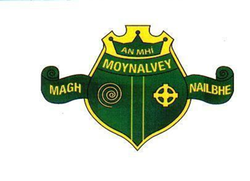
Scoil Mhuire,
Moynalvey
Summerhill,
Co. Meath
A83KD8

Telephone: 046 9557416/ 0830861407
Email: office@moynalveyns.ie
Charity No: 20131579
Roll No :18344i

Principal Mícheál Brennan
Vive Principal Anna Flynn

Scoil Mhuire Moynalvey
Annual Admission Notice for 2026 – 2027

Copies of the school’s Admission Policy and the Application Form for Admission for the 2026/27 school year are available as follows: – To download at: www.moynalveyns.ie
On request: By emailing: office@moynalveyns.ie.

1. Application and Decision Dates for Admission to junior infants for 2025/2026

1 | The school will commence accepting applications for admission on | 12th January
2 | The school will cease accepting applications for admission on | 20th February (Close of business 17:00)
3 | Applicants will be notified in writing of the decision on their application by | 6th March
4 | Applicants must confirm acceptance of an offer of admission by | 20th March (Close of business 17:00)

