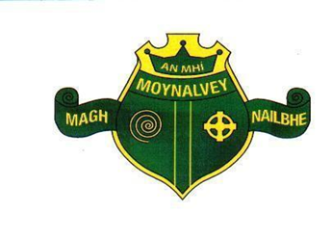

*Scoil Mhuire,*

*Moynalvey*

*Summerhill,*

*Co. Meath*

*A83KD8*

*Telephone: 046 9557416/ 0830861407*

*Email:* [*office@moynalveyns.ie*](mailto:office@moynalveyns.ie)

*Charity No: 20131579*

*Roll No :18344i*

*Principal Mícheál Brennan*

*Vive Principal Anna Flynn*

Scoil Mhuire Moynalvey

Annual Admission Notice for 2025 – 2026

Copies of the school’s Admission Policy and the Application Form for Admission for the 2025/26 school year are available as follows: – To download at: www.moynalveyns.ie

On request: By emailing: [office@moynalveyns.ie](mailto:office@moynalveyns.ie).

**1. Application and Decision Dates for Admission to junior infants for 2025/2026**

|  |  |  |
| --- | --- | --- |
| **1** | The school will commence accepting applications for admission on | **13th January** |
| **2** | The school will cease accepting applications for admission on | **21st February (Close of business 17:00)** |
| **3** | Applicants will be notified in writing of the decision on their application by | **7th March** |
| **4** | Applicants must confirm acceptance of an offer of admission by | **21st March (Close of business 17:00)** |