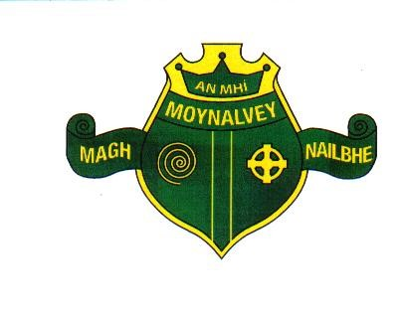

Moynalvey NS,

Moynalvey,

Summerhill,

Co. Meath

A83KD81

office@moynalveyns.ie

083 0861407 /046 9557416

Principal: Mrs. Maura Dineen

Deputy Principal: Ms. Anna Flynn

Roll number 18344I

**S.N. Mhuire, Moynalvey**

**ANNUAL ADMISSION NOTICE**

**In respect of admissions to the 2023/2024 school year**

Application and Decision Dates for admissions to 2023/2024 school year.

The following are the dates applicable for admissions to junior infants.

|  |  |
| --- | --- |
| The school will start accepting applications on | 16th January 2023 |
| The school will cease accepting application for admissions on | 24th February 2023 |
| The date which applicants will be notified of the decision on their application is | 23rd March 2023 |
| The period within which the applicants must confirm acceptance of an offer of admission | 31st March 2023 |
| **The school will consider and issue decisions on late applications in accordance with the schools admission policy** | |

Number of places being made available in 2023/2024

|  |  |
| --- | --- |
| The number of places being made available in junior infants is | 20 |